- Bisection Method
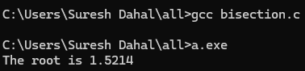
- Newton Raphson Method
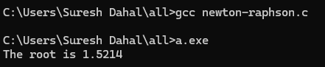
- Secant Method
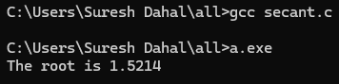
- Lagrange Interpolation
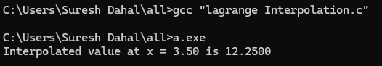
- Newton Forward Interpolation
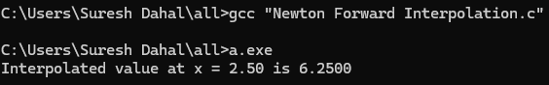
- Newton Backward Interpolation
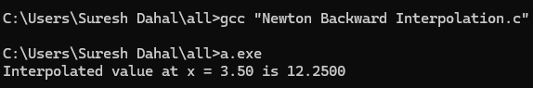
- Newton Divided Difference
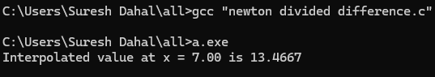

- Trapezoidal Rule
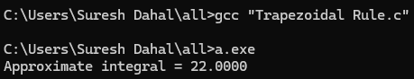
- Simpson’s 1/3 Rule
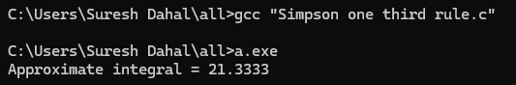
- Simpson’s 3/8 Rule
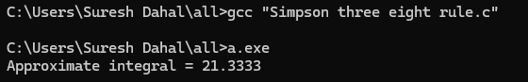
- Gauss Elimination Method
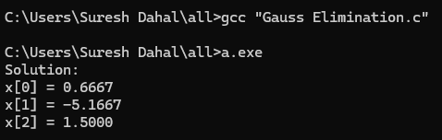
- Gauss-Jordan Method
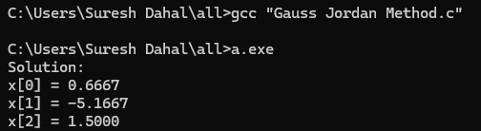

- Matrix Factorization using Doolittle LU Decomposition
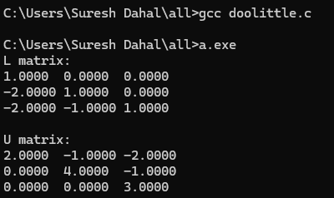
- Matrix Factorization using Cholesky’s Method
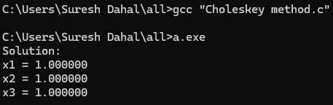
- Jacobi Iterative Method
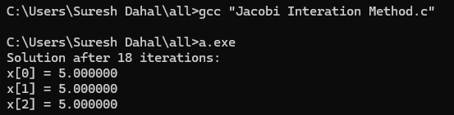
- Gauss-Seidel Iterative Method
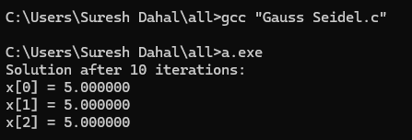

- Power Method
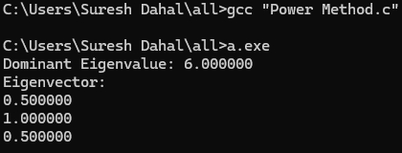
- Taylor Series Method for ODE
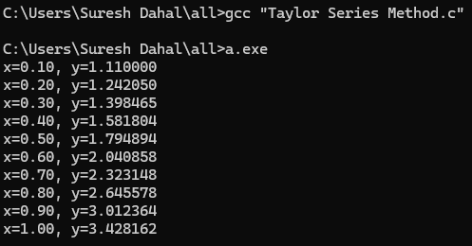
- Picard’s Method
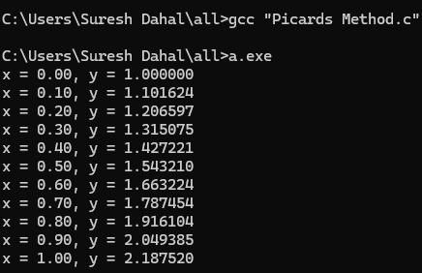

- Euler’s Method
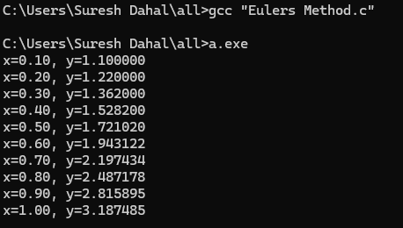
- Heun’s Method
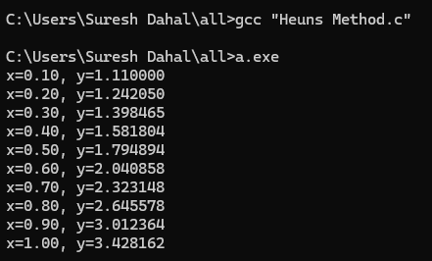

- Runge-Kutta Method (4th order)
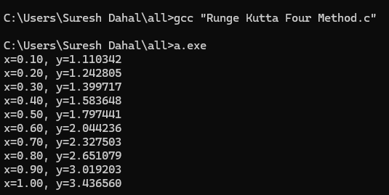
- Boundary Value Problem (Using Finite Difference Method)
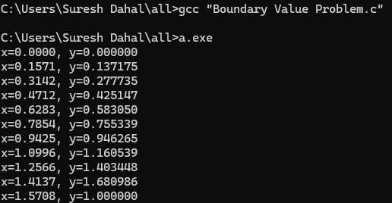
- Shooting Method
